University of Massachusetts Dartmouth
Department of Computer and Information Science

A Real-Time Reliability Model for Ontology-Based
Dynamic Web Service Composition

A Thesis in
Computer Science
by
Harmeet K Chawla

Submitted in Partial Fulfillment of the
Requirements for the Degree of
Master of Science

May 2011

I grant the University of Massachusetts Dartmouth the non-exclusive right to use
the work for the purpose of making single copies of the work available to the public
on a not-for-profit basis if the University's circulating copy is lost or destroyed.

_____________________________________
Harmeet K Chawla

Date _________________________________

We approve the thesis of Harmeet K Chawla
Date of Signature
_________________________________________ ____________________
Haiping Xu
Associate Professor, Department of Computer and Information Science
Thesis Advisor

_________________________________________ ____________________
Xiaoqin Zhang
Associate Professor
Graduate Program Director, Department of Computer and Information Science
Thesis Committee

_________________________________________ ____________________
Ramprasad Balasubramanian
Associate Professor, Department of Computer and Information Science
Thesis Committee

_________________________________________ ____________________
Jan Bergandy
Professor
Acting Chairperson, Department of Computer and Information Science

_________________________________________ ____________________
Robert E. Peck
Dean, College of Engineering

_________________________________________ ____________________
Alex J. Fowler
Associate Provost for Graduate Studies
ABSTRACT
Web services are reusable software components that can be used to integrate business applications over the Internet. When a single web service is not sufficient in providing the needed functionalities, multiple web services must be configured and integrated to work together as a high-level one. Ontology-based web service composition is a formal technique that allows for integration of available web services based on their semantic meanings. In order to evaluate the quality of composite web services at runtime, there is a pressing need to define a feasible real-time web service reliability model. In this thesis, we present such a model. We first introduce a dynamic process model that supports the evaluation of web service reliability. Then we provide a hybrid reliability model for atomic web services by considering both software and hardware aspects of the services. In order to calculate efficiently the reliability of ontology-based dynamic composite web services, we present a recursive algorithm that evaluates the reliability of various service composition constructs in real-time. Finally, we use a case study of financial investment to show how to compute and monitor the reliability of composite web services in real-time, and how our approach supports reliable ontology-based dynamic web service composition.

TABLE OF CONTENTS
TABLE OF FIGURES vii
ACKNOWLEDGEMENTS x
Chapter 1: INTRODUCTION 1
Chapter 2: RELATED WORK 6
Chapter 3: BACKGROUND KNOWLEDGE 10
3.1 Introduction to Web Services 10
3.2 Introduction to Ontology 12
3.3 Introduction to Universal Description, Discovery and Integration (UDDI) 14
3.4 Introduction to Mutual Funds 15
Chapter 4: ONTOLOGY-BASED WEB SERVICE COMPOSITION 18
4. 1 Ontology-Based Dynamic Web Service Composition: A Basic Framework 18
4.2 Dynamic Process Model 20
4.2.1 Formal Definition 20
4.2.2 Service Composition Constructs 24
4.3 Instantiation of PMT into IPM 28
Chapter 5: REAL-TIME SERVICE RELIABILITY EVALUATION 36
5.1 Reliability Parameters 36
5.2 A Hybrid Reliability Model for Atomic Web Services 38
5.3 Reliability Model for Composite Web Services 41
5.3.1 Sequence 42
5.3.2 Parallel 42
5.3.3 Loop 42
5.3.4 Choice 43
5.3.5 Redundancy 43
5.4 Algorithm: Composite Web Service Reliability Calculation 44
Chapter 6: CASE STUDY 46
6.1 Process Model 46
6.1.1 Choice 1: Mutual funds 46
6.1.1 Choice 2: Stocks 47
6.2 Graphical User Interface (GUI) 48
Chapter 7: CONCLUSIONS AND FUTURE WORK 61
REFERENCES 63

TABLE OF FIGURES
Figure 1. OWL-S Service description organization 14
Figure 2. Basic Framework for Ontology based WS composition 19
Figure 3. Definition of PMT in BNF 23
Figure 4. PMT involving Sequence construct 26
Figure 5. An example of (a) parallel construct (b) loop construct 27
Figure 6. An example of (a) choice construct (b) redundancy construct 27
Figure 7. An example of PMT with multiple structural components 28
Figure 8. Instantiated Process Model of the PMT shown in figure 4 31
Figure 9. IPM’s Tree Structure 32
Figure 10. Algorithm of instantiating PMT into set of IPMs 33
Figure 11. Redundancy construct (Special case) 34
Figure 12. Redundancy construct (Ordinary case) 35
Figure 13. Software reliability over time (λ = 0.0001, ξ = 0.8) 39
Figure 14. Hardware reliability over time (α = 2, β = 0.00002) 40
Figure 15. Web service reliability over time 41
Figure 16. Algorithm 2: Calculation of reliability 45
Figure 17. A process model for financial investment 46
Figure 18. BuyStocks1 process model 48
Figure 19. Interface for monitoring real-time web service reliability 49
Figure 20. GUI showing the PMT file 50
Figure 21. GUI showing the Configuration details 51
Figure 22. Example of User Input (Mutual fund selected) 53
Figure 23. Output of executing IPM corresponding to user input in Fig. 20 54
Figure 24. Example of User Input (Stocks selected) 54
Figure 25. Output of executing IPM corresponding to user input in Fig. 22 55
Figure 26. Information Window displaying execution information 56
Figure 27. GUI after instntiation of PMT 57
Figure 28. IPM file displayed on clicking the IPM tab 57
Figure 29. Re-configuration of desired and marginal reliabilities 58
Figure 30. Menus of the Composite Components menubar 59
Figure 31. Process model for BuyStocks1 60
Figure 32. IPM file for BuyStocks1 60

ACKNOWLEDGEMENTS

Foremost, I would like to express my sincere gratitude to my Thesis Advisor, Dr. Haiping Xu for his continuous support for my Master’s thesis. Dr. Xu was always there to guide me even during the vacations. He always replied to my emails in a few minutes! He was always in support of having weekly meetings that lasted for two hours sometimes; I thank him for his time. For some periods of time when I was really sick, he kept a lot of patience and asked me to take care of my health first. In addition, he encouraged me to look into my research findings very carefully so that I could write a good thesis. I could not have imagined having a better advisor for my thesis.
My sincere thanks are also extended to my thesis committee members: Dr. Ramprasad Balasubramanian and Dr. Xiaoqin Zhang for agreeing to be a part of the Thesis committee.
I would also like to thank my friends who have supported me through thick and thin. Last but not the least, I would like to thank my family: parents, sister, brother and cousins for always being there for me when I needed them the most, for having faith in me and for their sacrifices.

Chapter 1

INTRODUCTION
Service-oriented computing has become more and more popular among different organizations for implementation of Internet based business functions. Web services are self-contained software components that can be published, discovered and invoked over the Internet. Web service techniques have become very popular among different organizations for implementation of their services over the Internet. In many cases, a standalone web service is not sufficient to provide the needed functionality for certain user requirements [1]. This leads to the idea of composing different web services in order to meet such requirements. The process of web service composition can be either static or dynamic. In a static service composition, the services are pre-determined during the design phase; while in a dynamic service composition, only the service template can be initially defined, but the available services associated with the components defined in the template must be determined at runtime by searching the registries such as UDDI (Universal Description, Discovery and Integration) [2]. Since there is an increasing number of web services deployed over the Internet, which are volatile and dynamic in nature, it is important for a service-based system to detect available web services at runtime. Also, service composition must be done at runtime since the associated low-level web services are dynamic in nature and must be discovered in real-time. This would require a service-oriented system to have the capability to discover available web services at runtime and automatically compose them into a high-performance service on-the-fly. In order to discover, invoke, compose and monitor web services with a high degree of automation, we can use the semantic and ontological techniques [3]. In this thesis, we adopt the semantic markup language for web services (OWL-S) to formally specify the semantics of web services using ontology. Ontology is basically a precise description of web information and the relationships between different concepts. Such a specification makes the definitions of web services machine-understandable, and thus, it may support automated web service composition [4].
Many web services deployed over the Internet by different service providers perform similar or exactly the same tasks. In order to develop reliable composite web services, it is important to search and select the most suitable ones from the available services that meet the specified service requirements. Typically functional properties of a web service (formal specification of what exactly the service can do) are not sufficient for a customer to make a decision on adoption of the service for service composition [5, 6]. Nonfunctional properties such as service reliability (the probability that it will execute successfully while maintaining the agreed level of quality) are also critical to ensure the proper functioning of the composite web service. Reliability of a web service is the probability that it will execute successfully while maintaining the agreed level of quality.
The functional and non-functional properties of web services can be formally specified using OWL-S profiles, which allows for the structured representation of properties that are used to describe features of the service. OWL-S profile can be used for advertising and discovering services. An OWL-S profile describes three aspects of services. The first one is the functional aspect which includes inputs, outputs, preconditions, and effects. The second aspect is the classification aspect which supports the description of the type of service. The third aspect of the profile covers the non-functional aspect like reliability, which enables us to compare different web services that deliver the same functionality, but in different ways or with different performance characteristics [4]. OWL-S profiles can be published and stored in an ontology-based registry such as an OWL-S/UDDI so that when a service client searches it, services with matching profiles can be discovered and the corresponding grounding information can be retrieved. Since there may be more than one matched profiles published in an OWL-S/UDDI, a service client select one of them to achieve the desired task based on their nonfunctional properties such as service reliability. This would require the calculation of service reliability in real-time.
In this thesis, we provide a hybrid reliability model for atomic web services, which considers both software and hardware aspects of the services as both of them would affect the reliability of a web service. To calculate the reliability of composite web services, we design an efficient recursive algorithm that evaluates various service composition constructs in real-time. By employing a real-time reliability model for service composition, our approach not only supports the selection of desirable web services for dynamic web service composition, but also provides an effective way to monitor the reliability of both atomic and composite web services in real-time. Thus, it may potentially support re-composition of web services at runtime when the quality of service (QoS) of a composite web service or its constitutive service components becomes unacceptable. The reliability related parameters of an atomic web service are stored in the OWL-S profile that can be accessed at runtime, thus its service reliability can be calculated in real-time. The aggregated reliability of a composite web service depends on its structure, the degree of independence between services, and the availability of substitutes of web services [7].
The composition of web services is process-driven, which means business logic of a composite web service is formulated as a process model [8]. A process model describes how a service performs its tasks. It includes information about Inputs, Outputs, Preconditions and Results or Effects of a web service. Preconditions are circumstances that must hold before a service can be used and Results are changes brought about by a service. For example, in order to complete a sale, any product selling service would require a credit card number and expiration date as input. It is also important to check if the credit card is valid (precondition to the sale). After the sale, the buyer gets the receipt as an output confirming proper execution of the transaction and as effect, the book would be transferred from warehouse to the buyer’s address. The process model of a composite process shows how it breaks down into simpler component processes, and the flow of control and data between them. We have defined our own dynamic process model. We first define a process model template (PMT) which defines the components and the structure of the composite web service. These components are not bound to a specific web service. Specific service implementations are searched based on the query template of each component at runtime. We have taken into consideration four basic composition constructs namely Sequence, Parallel, Choice and Loop. To support fault-tolerant composite web services, we have also introduced a new construct namely Redundancy construct.
The rest of the thesis is organized as follows. We discuss the related work in Section 2. Section 3 discusses the background knowledge that is useful for fully understanding our approach. Section 4 describes the framework of our approach and the formalization of the dynamic process model. The real-time reliability model is described in Section 5. We demonstrate our approach with a case study in Section 6. In section 7, we summarize our conclusions and discuss future work.

Chapter 2

RELATED WORK
To establish a global component market for facilitating extensive software reuse, web service composition is gaining increasing attention from both academia and industry. If the implementation of a web service’s business logic requires the invocation of multiple web services, it is necessary to combine their functionalities. This combination is referred to as a composite service, and the process of developing a composite service is called service composition. Service composition involves composition of elementary or composite services [1]. The available web services may also change constantly so it is important that the web service specification is not bound to a web service during design time. This issue is addressed by runtime selection of service components according to the criteria specified by the user [8].
Service reliability has been an important measure of the quality of web services for service composition. There are many different kinds of existing software reliability models for web services. The most important are the ones in which software fault correction is involved and software reliability growth is experienced. Li et al. developed a user-oriented software reliability model for evaluating the reliability of web services [9]. Their approach can be used to evaluate the reliability of atomic web services based on an extended UDDI model and to predict the overall reliability of a composite web service using a Business Process Execution Language (BPEL)-specified structure. They introduced the extended UDDI model because the current UDDI metadata system tModel only includes some basic technical information provided by the service providers which the users do not trust completely. They extended UDDI by capturing log information and statistical data. Using this information, they calculated the reliability of the atomic web service and the transition failure rate. For computing the reliability of composite web service, they analyzed all possible structural relations in a WS-BPEL. Tsai et al. proposed a software reliability model that could dynamically evaluate the reliability of atomic and composite web services [10]. The model first calculates the reliability of atomic services by using group testing and majority voting, and then the overall reliability of a composite service by using an architecture-based model. In their approach, during the time the composite web service is functional, there is a continuous check for any newly registered web services that perform the same task as any component service. If any such web services are found, all the functionally equivalent services are tested in a group by forwarding a same input to all of them. Then, their results are voted by a voting service. Hwang et al. argued that most of the existing work was based on the assumption that each web service had a deterministic QoS (Quality of Service) [11]. To avoid such a limitation, they proposed to model the QoS as a random variable and estimate it probabilistically. Zo et al. examined the reliability for service selection [7]. Based on a process structure, they provided a mechanism to derive aggregate process reliability from the individual service reliabilities.
All of the above approaches consider only the software aspect of web services and assume the reliabilities of the machines that host the web services are near perfection. Furthermore, in the above approaches, the reliability evaluation of a composite web service is typically based on BPEL-like architectures that require static binding of available web services with the service components defined in a process model at design time. Thus, these approaches do not support dynamic web service composition. In contrast, our approach considers both software and hardware aspects of service reliability. Furthermore, since our approach supports ontology-based web service composition, it provides a feasible way for maintaining reliable composite web services at runtime.
There are also many previous efforts on ontology-based web service composition and formal modeling of dynamic service composition. Jeon et al. proposed to use web service ontology to support ubiquitous environment [3]. They introduced a method to describe web services considering both of their functional and semantic aspects, and implemented a service interlocking and composition system that could support the composition of heterogeneous web services. Ma et al. introduced an ontology-based model for web service composition, called OMWSC [12]. They presented a goal-driven and ontology-based architecture that could support automatic composition of web services. Xiong et al. presented a service functional configuration net based on Petri nets for automatic service composition [13]. They described the configuration specification for component services through the structure of disassembly Petri nets, and obtained the optimal one using linear programming. Tan et al. introduced a formal method to derive possible web service composition candidates based on a service portfolio [14]. They first generated a service net (SN) containing all needed operations, and then used Petri net decomposition techniques to derive a subnet of SN that meets the business requirements.
Although the above approaches support dynamic web service composition, most of them consider only the functional requirements for service composition, and none of them attempted to use service reliability as a major criterion for service selection. Different from the above approaches, we developed a real-time service reliability model for ontology-based web service composition. Thus, our approach supports composition of reliable web services at runtime.
Previous work on real-time software reliability evaluation is rare. Jin et al. proposed an approach for the real-time performance analysis of distributed software with reliability constraints [15]. In order to evaluate the real-time performance of distributed software, they designed an algorithm to calculate the response time of each data file with reliability constraints by recording the transmission time for all transmission paths. Geist et al. used a simulation-based method to obtain an estimate of real-time software reliability [16]. They used an extended stochastic Petri net to represent the synchronization structure of the software, and derived the distributions of execution times from automatically generated test cases.
Although the above approaches addressed the issue of real-time evaluation of software reliability, to the best of our knowledge, there is no previous work on real-time reliability evaluation for service-oriented systems. By defining a real-time reliability model for composite web services, our approach provides a feasible way for evaluating the reliability of service-oriented systems in real-time.

Chapter 3

BACKGROUND KNOWLEDGE

3.1 Introduction to Web Services
Web services provide a standard way of integrating web-based applications using XML, SOAP, WSDL and UDDI open standards over an internet protocol backbone. We now briefly described the open standards as follows:
- XML (Extensible Mark-up Language) allows designers to create their own customized tags, enabling the definition, transmission, validation, and interpretation of data between applications and between organizations.
- SOAP (Simple Object Access Protocol) is an XML based messaging protocol used to encode the information in web service request and response messages before sending them over the network.
- WSDL (Web Services Description Language) is an XML formatted language used to describe a web-service’s capabilities
- UDDI (Universal Description Discovery and Integration) is a web-based distributed directory that enables businesses to list themselves on the internet and discover each other just like phonebook’s yellow and white pages. jUDDI (pronounced "Judy") is an open source Java implementation of the Universal Description, Discovery, and Integration specification for Web Services [17].
JAX-WS (Java API for XML Web Services) is a Java programming language API for creating web-services. JAX-WS represents remote procedure calls or messages using XML-based protocols such as SOAP, but hides their complexity behind a Java-based API. The JAX-WS runtime system converts API calls and matching replies to and from SOAP messages.
JAX-WS is a fundamental technology for developing SOAP (Simple Object Access Protocol) and RESTful (Web services that use representational state transfer, or REST, tools) Java Web services, where JAX-WS is designed to take the place of the JAVA-RPC (Remote Procedure Call) interface in Web services and Web-based applications. JAX-WS is also used to build Web services and corresponding clients that communicate using XML to send messages or use remote procedure calls to exchange data between client and service provider.
JAX-WS is an important part of the Java EE 5 platform. It is a follow-up to the release of Java API for XML-based RPC 1.1(JAX-RPC). The advantages of using JAX-WS are listed below:
- JAX-WS simplifies the task of developing web services using Java technology.
- It addresses some of the issues in JAX-RPC 1.1 by providing support for multiple protocols such as SOAP 1.1, SOAP 1.2, XML, and by providing a facility for supporting additional protocols along with HTTP.
- JAX-WS uses JAXB 2.0 for data binding and supports customizations to control generated service endpoint interfaces.
- JAX-WS reduces the size of runtime JAR files [18].

3.2 Introduction to Ontology
Ontologies are used to capture and describe the knowledge about some domain of interest. Ontologies are represented in logical languages such as OWL (Web Ontology Language), which is machine-understandable. Ontology describes the concepts in the domain and also the relationships that hold between those concepts. Classes are the most important focus of most ontologies as they describe the concepts in the domain. For example, a class of pizza represents all pizzas. Specific pizzas are instances of this class. The Cheese Pizza is an instance of the class of Cheese Pizzas. Classes may be organized into a Superclass-subclass hierarchy, which is also known as taxonomy. Subclasses specialize (‘are subsumed by’) their Superclasses. For example, we can divide the class of all pizzas into vegetarian and non-vegetarian. Consider the classes Pizza and Cheese Pizza – Cheese Pizza is a subclass of Pizza (so Pizza is the superclass of Cheese Pizza). This says that, ‘All Cheese Pizzas are Pizzas’, ‘All members of the class Cheese Pizza are members of the class. Alternatively, we can make a division on basis of different properties of pizza too [19]. The benefits of creating Ontology are listed as follows:
- To make domain assumptions explicit
- To share common understanding of the structure of information among people or software agents
- To enable reuse of domain knowledge
- To analyze domain knowledge
OWL-S is an ontology of service concepts that supplies us with markup language constructs for describing the properties and capabilities of a web service in unambiguous, computer-interpretable form. OWL-S introduces ontologies to describe the concepts in the services' domain as well as generic concepts to describe the services themselves and how they relate to the domain ontologies (via inputs and outputs, preconditions and effects, and so on). These semantically rich descriptions support automation of service discovery, composition, and execution thereby reducing manual efforts [20].
OWL-S organizes a service description into four conceptual areas (shown in Fig. 1):
- Process model
A process model describes how a service performs its tasks. It includes information about inputs, preconditions and results. The process model differentiates between composite, atomic, and simple processes.
- Profile
A profile tells “what the service does.” Profiles can include both functional properties (inputs, outputs, preconditions, and results) and nonfunctional properties (service name, text description, contact information, service category, and additional service parameters).
- Grounding
Grounding specifies how a service is invoked i.e. a way to access it.
- Service
A service simply binds the other parts together into a unit that can be published and invoked [21]. It tells ``how the service works''.
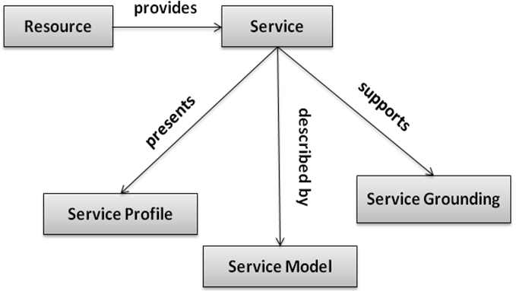

Figure 1. OWL-S Service description organization

3.3 Introduction to Universal Description, Discovery and Integration (UDDI)
UDDI is a platform-independent, XML-based registry for businesses worldwide to list them on the Internet. UDDI enables businesses to publish service listings and discover each other. It also defines the interaction mechanism between the services or the service applications over the Internet.
A UDDI business registration consists of three components:
- White pages
They give information about the business supplying the service. The information includes name of the business, business contact information (address, phone number) and description of the business. Knowing this information makes it possible to find a service.
- Yellow pages
The yellow pages classify the service or business based on standard taxonomies (For e.g. United Nations Standard Products and Services Code (UNSPSC)). More than one yellow page could be associated with one white page if a business provides multiple numbers of services.
- Green pages
Green pages provide a way to access the web service. They provide information about the service bindings, service address and parameters etc [22].
With the increasing use of web services, there was a need to develop an effective discovery mechanism to search for services that will satisfy our requirement. UDDI provides a web wide registry of web services, but its lack of an explicit capability representation and its syntax based search produced course results. So, a discovery mechanism based on OWL-S was developed that allows us to semantically describe web services in terms of its capabilities offered. An OWL-S/UDDI combines the better of two technologies.
The OWL-S/UDDI client allows an application to interact with the OWL-S/UDDI server. Major tasks that can be performed via the client include the following:
- Publishing profiles in the OWL-S/UDDI
- Querying the OWL-S/UDDI
- Removing the profile form OWL-S/UDDI [23]

3.4 Introduction to Mutual Funds
A mutual fund is a company that pools money from investors and invests the money in different types of investments like stocks, bonds and other securities. The combined holdings of the mutual fund are known as its portfolio. Each mutual fund has different risks and rewards. The higher the reward, the higher the risk involved. There are three fundamental types of mutual funds based on the risk involved, they are listed as follows:
- Equity mutual funds
Equity funds involve high risk factor as they invest mostly in stocks. The investment objective of this type of fund is to achieve long-term growth. As the stocks market fluctuates a lot, over a long period of time, the profits are expected to outweigh the losses incurred.
- Debt mutual funds
Debt funds have the least risk involved. The main objective of this class of funds is to provide income on a steady basis. These funds are good for conservative investors, old-aged people and retirees who require a steady cash flow and are not willing to or cannot afford to incur large losses.
- Balanced mutual funds
The objective of the balanced funds is to provide a balance between safety and income. The strategy is to invest in combination of fixed income securities and equities. Generally, 60% of money is invested in equities and the left 40% in fixed income, although this distribution can vary for different companies.
Investing money in mutual funds makes the task of investor a lot easier as the investor does not need to research on the market and diversify the investment by himself. Some advantages of mutual funds are listed below:

- Professional Money Management
The most important reason why investors prefer to invest their money in mutual funds is that their money is being managed professionally by experts. These experts are continuously researching market for newer and better investment opportunities. Investors who do not have time or expertise can also get guidance from Investment Advisors who can help in deciding which mutual fund to invest in.
- Diversification
Since mutual funds invest their money in different types of investments, the risk is diversified. The main idea involved is to be able to minimize expected loss (due to risk involved) in an investment by the gain in others.
- Economies of scale
Mutual funds buy and sell large amounts of securities at a time. So, the transaction costs are lower than what it would cost an individual to pay for security transactions.
- Liquidity
Mutual fund allows investors to encash their investments any time they want [24].

Chapter 4

ONTOLOGY-BASED WEB SERVICE COMPOSITION

4. 1 Ontology-Based Dynamic Web Service Composition: A Basic Framework
The service environment is highly flexible and dynamic. If there is any change in the existing service that is being used as a part of the web service composition with respect to its inputs, outputs, preconditions or post conditions, inconsistencies are bound to occur. So, the web service composition should be dynamic so as to adapt to the environment changes.
Specifying service related information semantically is the key to effective dynamic service discovery and service composition. Web service description language (WSDL) can be used to describe the syntax of a web service such as its input and output parameters, as well as related information such as the service provider and the service endpoint address; however, it does not support specifying the semantics of a web service. Therefore, WSDL has its limitations in supporting the dynamic service discovery, execution, composition and interoperation of web services. On the other hand, ontology-based techniques can not only be used to describe the syntax but also the semantics of web services. In ontology-based semantic modeling, the terms used in the concerned domain can be precisely defined, relations can be established between them and thus services can be matched based on their semantics rather than their syntax or keywords [1].
Fig. 2 shows the basic framework for ontology-based dynamic web service composition with a simple process model. In the process model, A and B are web service components defined in a sequence construct. The components A and B can only be bound to specific web services at runtime. Thus, the process model is defined as a template, called a Process Model Template (PMT).
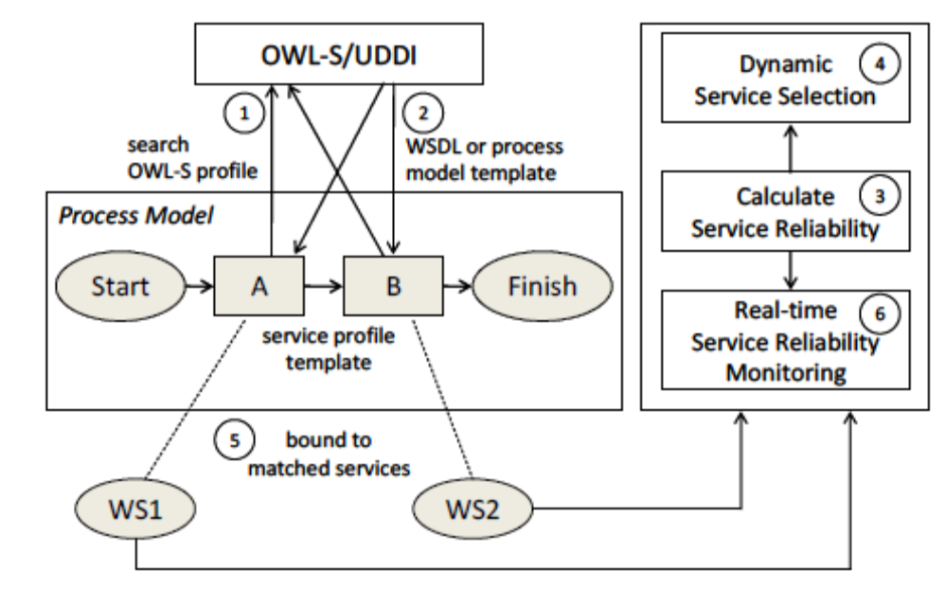

Figure 2. Basic Framework for Ontology based WS composition
In order to instantiate the PMT into an Instantiated Process Model (IPM), we need to search available web services for its constitutive service components. For this purpose, each service component (i.e., A and B in this example), which is also called a simple component, is associated with an OWL-S profile template. An OWL-S profile template is essentially an incomplete OWL-S profile with semantically defined input, output, preconditions and effects so that it can be matched with existing OWL-S profiles published in the OWL-S/UDDI. Based on the grounding information associated with the published service profiles, a simple component can be bound to a specific web service deployed over the Internet. For example, in Fig. 2, the simple components A and B are bound to web services WS1 and WS2, respectively. Note that in this example, the matched web services are atomic web services. When a matched web service is a composite one, it is also defined using a PMT which must be instantiated further. This procedure repeats until all matched web services become atomic. In this case, the process of instantiating the PMT becomes complete.
As mentioned previously, a profile template can be matched with more than one published OWL-S profiles in OWL-S/UDDI, but only the most desirable one is selected for execution. The criteria for service selection can be based on multiple features, such as provider, reliability, and price; however, for simplicity, in this thesis, we only consider the reliability as the sole criterion for service selection. Since service reliability is a dynamic property, it requires the system be able to calculate it in real-time. This serves two purposes, namely the selection of web services for dynamic service composition and the real-time monitoring of web service reliabilities. With the monitoring function, a service-oriented system can be maintained to be reliable continuously – when the reliability of some web services drop to an unacceptable level, they can be replaced by other reliable ones at runtime.

4.2 Dynamic Process Model

4.2.1 Formal Definition
A PMT is defined as a dynamic process model that consists of structural components, such as a sequence component and a parallel one. Each structural component contains simple components and possibly other structural ones. A simple one is represented as a rectangle in a PMT (e.g., components A and B in Fig. 2). PMT has some placeholders which are empty tags related to information about each component. They are filled at runtime when the components are bound to either an atomic web service or a composite one. Since the tag values are filled during execution, our process model is dynamic in nature.
The PMT is formally defined using Backus-Naur form (BNF) as in Fig. 3. As shown in the definition of PMT, the reliability requirements for a process model are described by using two parameters, namely <DesiredReliability> and <MarginalReliability>. The former defines the desired reliability of an instantiated process model (i.e., a composite web service). A composite web service with at least the desired reliability is considered to be reliable. On the other hand, a composite web service with at least the <MarginalReliability> is considered as not reliable but is acceptable for a temporary usage. In this case, the application must try to search for more reliable substitutes in order to build a reliable composite web service. If it fails, a warning must be sent to the user of the application. Furthermore, when the reliability of a composite web service becomes less than the marginal reliability, the composite web service becomes unacceptable and must stop its execution.
The structure of the process model is defined between the <Process> start and end tag. A structural component can be one of the five major composition constructs, namely sequence, parallel, loop, choice, and redundancy. The first four are basic structural components defined for composite web services [7, 10], whereas the redundancy construct is a newly introduced one, which supports the development of reliable composite web services. Using Redundancy construct, we can keep a list of functionally equivalent (redundant) web services as a backup such that if the main web service stops working, the application can quickly switch to one of the redundant services. Redundant services are very useful for applications with time-critical services as an immediate backup, because using them; the applications can significantly reduce the switching time by avoiding searching OWL-S/UDDI for other matching services at runtime.
Each simple component of the process model is linked with its <SimpleMapping> which has a set of placeholders for the mapping information that details how a simple component can be bound to a selected web service. The mapping is done using the unique component’s id. Since before instantiation of the PMT, the components are not bound to any web service, the only item that is filled inside <SimpleMapping> is the <Owl-sProfileTemplate> which contains the profile template location of the component. Using this profile template location, OWL-S/ UDDI is queried for finding any available matching web services. All the other items inside <SimpleMapping> are placeholders which are filled after instantiation of the PMT at runtime. These are explained in
Section 4.3: Instantiation of PMT into IPM.
Figure 3. Definition of PMT in BNF
<PMT> ::= <ProcessModelTemplate> <DesiredReliability> <MarginalReliability>
<Process model> <Simple component mapping>
{<Simple component mapping>} </ ProcessModelTemplate>
<DesiredReliability> ::= <float>
<MarginalReliability>::= <float>

<Process model> ::= <Process> <Structural component> </Process>
<Structural component> ::= <Sequence component> | <Parallel component>|
<Loop component> | <Choice component> |
<Redundancy component>
<Sequence component> ::= <Sequence> <component> <component> {<component>}
</Sequence>
<Parallel component> ::= <Parallel> <component> <component> {<component>}
</Parallel>
<Loop component> ::= <Loop> <condition> <component> </Loop>
<condition> ::= <Boolean expression>
<Choice component> ::= <Choice> <component> <component> {<component>}
</Choice>
<Redundancy component> ::= <Redundant>
<Main> <component> </Main>
<Spare> <component> </Spare>
{<Spare> <component> </Spare>} </Redundant>
<component> ::= <simple component> | <structural component>
<simple component> ::= <Simple> <component id> </Simple>
<component id> ::= <string>

<Simple component mapping> ::= <SimpleMapping> <component id> < Owl-sProfileTemplate> <ServiceType> <FailureIntensity> <InitialReliability> <Shape> <Scale> <Date> <Time> <Real-timeReliability> <AtomicServiceGroundingInfo> <CompositeServiceGroundingInfo> </SimpleMapping>
<component id> ::= <string>
<Owl-sProfileTemplate> ::= <string>
<ServiceType> ::= ”Atomic” | ”Composite”
<FailureIntensity> ::= <float>
<InitialReliability> ::= <float>
<Shape> ::= <float>
<Scale> ::= <float>
<Date> ::= <date>
<Time> ::= <time>
<Real-timeReliability> ::= <float>
<AtomicServiceGroundingInfo> ::= <wsdl file>
<CompositeServiceGroundingInfo> ::= <ipm file>

4.2.2 Service Composition Constructs
Following is the description of the service composition constructs defined in the process model.
Sequence
In a sequence structural component, the constitutive components are executed in series. Fig. 2 includes an example with two simple components A and B, defined in the process model. The directed arrow between A and B indicates the order of execution. When one of the constitutive components in a sequence construct is not functioning, the entire sequence structural component is not. A PMT involving sequence construct would be defined as shown in Fig. 4.
Parallel
In a parallel structural component, two or more constitutive components can execute concurrently. The structural component terminates when all of its components have finished their execution. Fig. 5(a) shows a parallel structural component with two simple components A and B.
Loop
A loop structural component refers to the repetitive execution of a simple or structural component. As shown in Fig. 5(b), when the condition cond is evaluated to be true, simple component A is executed repetitively. Only when it becomes false, the loop construct terminates. Note that the “skip” component is an empty component that is used to separate the loop construct from other components.
Choice
In a choice structural component, only one of the constitutive components can be selected for execution. Fig. 6(a) shows an example of a simplified choice structural component with no guards (conditions). When guards are not defined, the component (A or B) to be selected for execution is determined manually by user inputs.
Redundancy
A redundancy structural component consists of a main component and one or more than one spare components, which can be used to make an application more reliable. Fig. 6(b) shows a simple example of a redundancy structural component, where simple component A is the main component, and B and C are the first and second spare components, respectively. When A becomes unacceptable, the first spare component B is used to substitute A. Similarly, if B also becomes unacceptable, C is activated to substitute B.

Figure 4. PMT involving Sequence construct
<ProcessModelTemplate>
<DesiredReliability> 0.8 </DesiredReliability>
<MarginalReliability> 0.6 </MarginalReliability>
<Process>
<Sequence>
<Simple> A </Simple>
<Simple> B </Simple>
</Sequence>
</Process>
<SimpleMapping ID="A">
<Owl-sProfileTemplate> http://192.168.1.112:8080/query/ATemplate.owl
</Owl-sProfileTemplate>
<ServiceType> empty </ServiceType>
<FailureIntensity> empty </FailureIntensity>
<InitialReliability> empty </InitialReliability>
<Shape> empty </Shape>
<Scale> empty </Scale>
<Time> empty </Time>
<Date> empty </Date>
<Real-timeReliability> empty </Real-timeReliability>
<AtomicServiceGroundingInfo> empty </AtomicServiceGroundingInfo>
<CompositeServiceGroundingInfo> empty
</CompositeServiceGroundingInfo>
</SimpleMapping>
<SimpleMapping ID="B">
<Owl-sProfileTemplate> http://192.168.1.112:8080/query/BTemplate.owl
</Owl-sProfileTemplate>
<ServiceType> empty </ServiceType>
<FailureIntensity> empty </FailureIntensity>
<InitialReliability> empty </InitialReliability>
<Shape> empty </Shape>
<Scale> empty </Scale>
<Time> empty </Time>
<Date> empty </Date>
<Real-timeReliability> empty </Real-timeReliability>
<AtomicServiceGroundingInfo> empty </AtomicServiceGroundingInfo>
<CompositeServiceGroundingInfo> empty
</CompositeServiceGroundingInfo>
</SimpleMapping>
</ProcessModelTemplate>

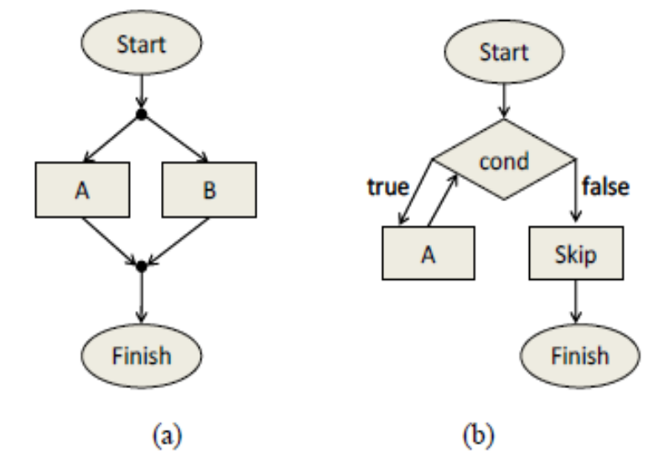

Figure 5. An example of (a) parallel construct (b) loop construct
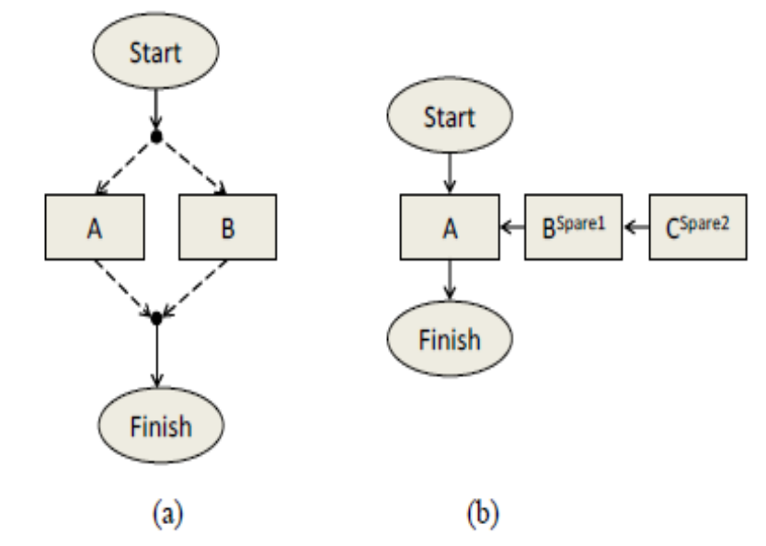

Figure 6. An example of (a) choice construct (b) redundancy construct
Fig. 7 shows an example of PMT with multiple structural components. The process model is defined as a parallel component with two sequence components defined as its constitutive ones, which can execute concurrently. The first sequence component consists of two components, namely simple component A and a choice structural component with two simple ones B and C. The second sequence component consists of two simple ones D and E.
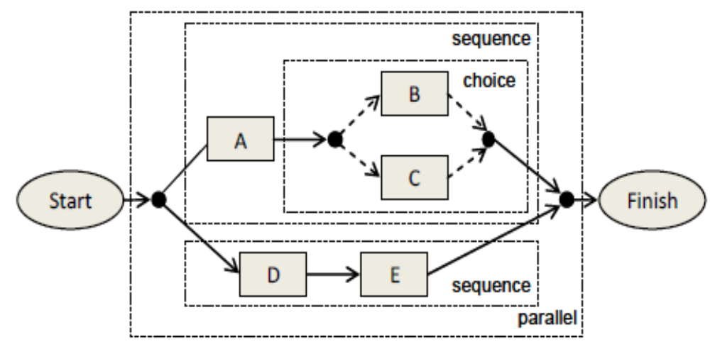
Figure 7. An example of PMT with multiple structural components

4.3 Instantiation of PMT into IPM
When a PMT is instantiated into an IPM, each simple component defined in the PMT needs to be bound to either an atomic web service described by a WSDL file or a composite one specified by another PMT. In Fig. 3, <ServiceType> parameter is the identification of the selected web service where the service type can be either: “Atomic” or “Composite” depending upon the type of the most reliable matched web service. If the selected web service is an atomic one, the placeholder <AtomicServiceGroundingInfo> must be filled with the address of its WSDL file.
Composite web services do not have a WSDL file; instead they have a process model template. So, when the most reliable match is a composite web service, then we can get its PMT from the OWL-S file and store it locally on our computer. This PMT also needs to be instantiated by invoking the external method InstantiatePMTintoIPM (defined in Algorithm 1, Fig. 10) recursively. When the selected web service is composite, the placeholder <CompositeServiceGroundingInfo > needs to be filled with the location of the IPM file that specifies the composite web service.
<FailureIntensity>, <InitialReliability>, <Shape>, <Scale>, <Date> and <Time> are all reliability related parameters of an atomic web service. Their values are extracted from the OWL-S profile of the selected atomic web service at runtime. These parameters are explained in detail in Section 5.1. The item <Real-timeReliability> is the reliability of the web service that is bound to a simple component. It is calculated using the above six reliability parameters for atomic web services during runtime. For composite web services, it is calculated using the external method CalculateReliability to be discussed in Section 5.4, Algorithm 2.
When all the placeholders are filled out with required information, we call it an Instantiated Process Model (IPM). The instantiation of PMT shown in Fig.4 is illustrated in Fig. 8. The PMT has components A and B in sequence. Querying the OWL-S/UDDI for component A fetched an atomic web service. So, the <ServiceType> was set to “Atomic”. Its WSDL was extracted from the OWL-S file and was filled in the
<AtomicServiceGroundingInfo>. The reliability related information was also gathered from the OWL-S profile and was filled in the respective parameters. Since the matched service is atomic so the < CompositeServiceGroundingInfo> tag is empty. Component B also matched with an atomic web service. The service related information for component B was filled out in the same manner.
Now, in this case both the components matched with an atomic web service. So, our PMT is fully instantiated. However, if components A and/ or B had matched with a composite web service, then their PMT(s) would be stored; instantiated and then the resultant IPM file would be linked with the components. Then, again if any component in the new PMT(s) linked with a composite web service, the process of instantiation would continue. It is like a tree structure.
Fig. 9 shows an example of the IPM’s tree structure. Block 1 has a part of the mapping information of components A and B. In this case, both of them matched with a composite web service. The PMT’s of both components were extracted and then instantiated. Components A and B were linked to C://A-ipm.owl and B-ipm.owl respectively. B-ipm has two components: C and D. When B-ipm was instantiated, C matched with a composite web service while D matched with an atomic one. Now, component C’s pmt was stored and instantiated. C was linked to C://C-ipm.owl. C-ipm only has one component G, which matched with an atomic web service. B-ipm is now fully instantiated. Now switching over to A-ipm; it only has one component E, which matched with a composite web service. The new pmt was stored and instantiated. Thereafter, E-ipm was linked to C://E-ipm.owl. Again, the only component F, in E-ipm, matched with a composite web service. This instantiation process continues until all the components of the IPMs at the leaves of the tree, match with an atomic web service.

Figure 8. Instantiated Process Model of the PMT shown in figure 4
<InstantiatedProcessModel>
<DesiredReliability> 0.8 </DesiredReliability>
<MarginalReliability> 0.6 </MarginalReliability>
<Process>
<Sequence>
<Simple> A </Simple>
<Simple> B </Simple>
</Sequence>
</Process>
<SimpleMapping ID="A">
<Owl-sProfileTemplate> http://192.168.1.112:8080/query/ATemplate.owl
</Owl-sProfileTemplate>
<ServiceType>Atomic</ServiceType>
<FailureIntensity> 0.09 </FailureIntensity>
<InitialReliability> 0.82 </InitialReliability>
<Shape> 2.0 </Shape>
<Scale> 0.004 </Scale>
<Time> 0:20:00 </Time>
<Date> 04/12/2011 </Date>
<Real-timeReliability> 0.9312 </Real-timeReliability>
<AtomicServiceGroundingInfo> http://192.168.1.112:8080/Aa/AService?wsdl
</AtomicServiceGroundingInfo>
<CompositeServiceGroundingInfo>empty
</CompositeServiceGroundingInfo>
</SimpleMapping>
<SimpleMapping ID="B">
<Owl-sProfileTemplate> http://192.168.1.112:8080/query/BTemplate.owl
</Owl-sProfileTemplate>
<ServiceType>Atomic</ServiceType>
<FailureIntensity> 0.09 </FailureIntensity>
<InitialReliability> 0.82 </InitialReliability>
<Shape> 2.0 </Shape>
<Scale> 0.038 </Scale>
<Time> 0:20:00 </Time>
<Date> 04/11/2011 </Date>
<Real-timeReliability> 0.9111 </Real-timeReliability>
<AtomicServiceGroundingInfo> http://192.168.1.112:8080/Bb/BService?wsdl
</AtomicServiceGroundingInfo>
<CompositeServiceGroundingInfo>empty
</CompositeServiceGroundingInfo>
</SimpleMapping>
</InstantiatedProcessModel>

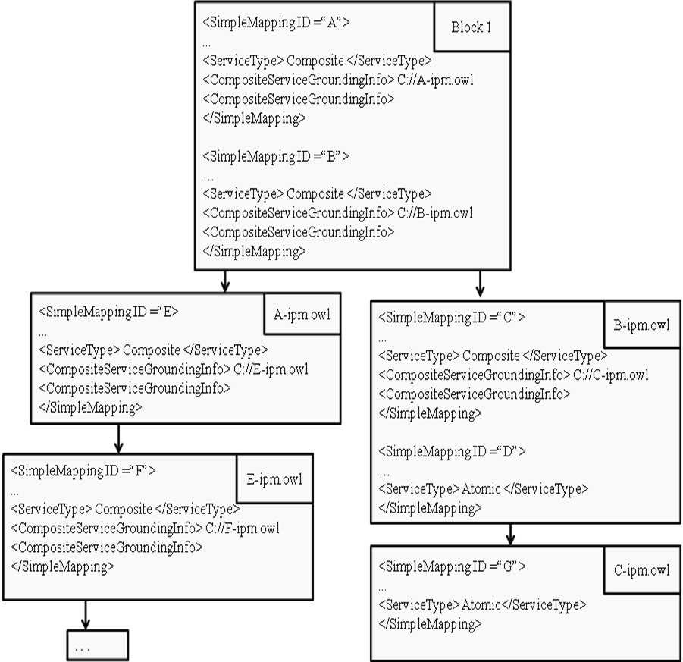

Figure 9. IPM’s Tree Structure
The algorithm for instantiating a PMT into a set of IPMs is defined in Fig. 10. It requires the path of the PMT file as an input. Note that it is defined recursively because a simple component can be mapped to a composite web service specified by another PMT file. In this case the PMT file must also be instantiated by invoking the method InstantiatePMTintoIPM recursively. As a result, the output of the algorithm is a set of IPM files organized in a tree-like structure. Furthermore, the instantiation process requires calculating web service reliabilities in real-time. This is because when more than one matched web services are discovered, their reliabilities need to be calculated in real-time, such that the most reliable one can be selected for execution. In order to calculate the reliability of a composite web service, an external method CalculateReliability (to be discussed in Section 5.4, Algorithm 2.) must be invoked.
Algorithm 1: Instantiate PMT into IPMs
Input: a pmt file’s path
Output: a set of ipm files arranged in a tree structure.
1. InstantiatePMTintoIPM (String fname.pmt)
2. copy contents of fname.pmt file to fname.ipm
3. extract the process model from file fname.pmt and store it in process_model
4. foreach simple component sc in process_model
5. initialize sc.realtime_reliability to 0
6. initialize service_index to 0
7. query OWL-S/UDDI using sc.profile_template
8. foreach matched web service ws
9. if (ws is atomic)
10. extract reliability parameters from OWL-S profile of ws
11. calculate ws.reliability for atomic web service ws
12. if (ws.reliability > sc.realtime_reliability)
13. store reliability parameters of ws
14. service_index = ws.index
15. sc.realtime_reliability = ws.reliability
16. sc.service_type = “Atomic”
17. else if (ws is composite)
18. store the PMT of ws at path ws.pmt
19. InstantiatePMTintoIPM (ws.pmt)
20. ws.reliability = CalculateReliability (ws.ipm, true, null)
21. if (ws.reliability > sc.realtime_reliability)
22. service_index = ws.index
23. sc.realtime_reliability = ws.reliability
24. sc.service_type = “Composite”
25. if (sc.service_type == “Atomic”)
26. extract wsdl_address from OWL-S profile of ws at service_index
27. set sc.wsdl_address to the wsdl_address extracted above
28. set the reliability parameters for sc to their stored values
29. else
30. set sc.ipm to the ipm file of ws at service_index
31. save the service info of sc into its placeholders in file at fname.ipm

Figure 10. Algorithm of instantiating PMT into set of IPMs
Algorithm 1 is the general algorithm for instantiating a PMT. But, there is a special case in which the instantiation is done in a slightly different manner. Following are the conditions for the applicability of the special case:
- The process model of the PMT has a redundancy construct
- The main and the spare components of the redundancy construct are simple components
- The main and the spare components share the same OWL-S Profile Template.

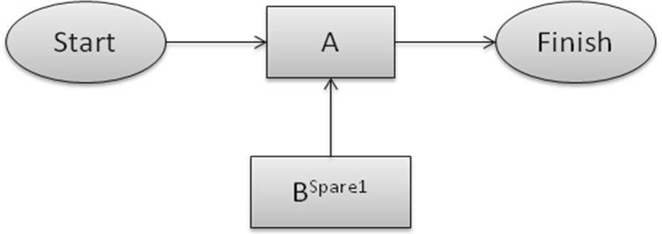
Figure 11. Redundancy construct (Special case)
In this case (also shown in Fig. 11), the main component of the redundancy construct A is instantiated according to Algorithm 1 but the spare components are instantiated differently. For the first spare component, here B^{Spare1}, the second best reliable service is selected as opposed to selecting the most reliable one. The reason for selecting the second best reliable service is that the most reliable one has been already assigned to the main component. And the purpose of spare component is to replace the main component when the main component stops working. If the spare component also matches with the very same web service as the main one, then there is no use of the spare component. Similarly, for the second spare component the third best reliable service is chosen. All the remaining spare components (if any) would be instantiated in the same manner.
Now, considering the case when the process model has the redundancy construct but the main and/or spare component(s) are not all simple components as shown in Fig. 12.

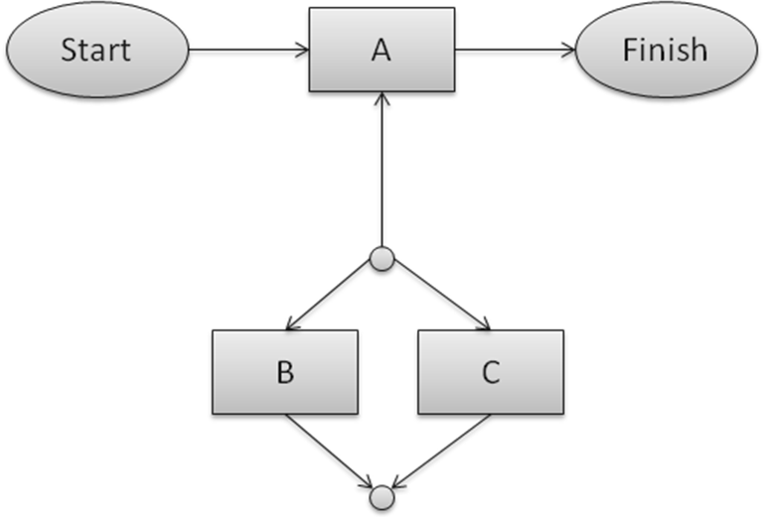

Figure 12. Redundancy construct (Ordinary case)
In this case, the main component A and the spare component consisting of B and C in parallel would not share the same OWL-S Profile Template because the task accomplished by A alone is equivalent to the task accomplished when B and C work in parallel. Hence A, B and C are all matched with the most reliable web services i.e. following the Algorithm 1.

Chapter 5

REAL-TIME SERVICE RELIABILITY EVALUATION
Service reliability represents an important attribute for the QoS of a web service deployed on a certain machine. In this thesis, we take into account both hardware and software aspects of service reliability as both are needed to determine the reliability of a deployed atomic web service. Then based on the reliability of the participating atomic web services, we can calculate the reliability of a composite web service according to its dynamic process model. We assume that reliability related parameters are published in the OWL-S profile of the atomic web service registered in OWL-S/ UDDI.

5.1 Reliability Parameters
In order to calculate the reliability of an atomic web service at a particular time, we define the following reliability related parameters in an OWL-S profile of an atomic web service:
The parameters used in calculating the software reliability (as in formula (1) mentioned in Section 5.2) are listed below:
- Software failure intensity (λ)
Failure intensity is defined as the number of failures experienced per unit "time" period. Sometimes, the term failure rate is used instead.

- Initial Reliability (ξ)
It is the reliability of the software component at t = 0. Its value lies between 0 and 1
(0 ≤ ξ ≤ 1).
The parameters used in calculating hardware reliability (as in formula (2) mentioned in Section 5.2) are listed below:
- Shape parameter (β)
It is sometimes known as the slope. It is a pure number and is dimensionless. Different values of the shape parameter can have marked effects on the behavior of the distribution.
- Scale parameter (α)
Change in the scale parameter has the same effect on the distribution as a change of the abscissa scale. It has same units as that of time.
Following parameters are very important for calculating both software and hardware reliability:
- Date
It is the deployment date of the web service. It is very important in calculating the reliability of the web service since reliability is time-dependent.
- Time
It is the time at which the web service was deployed. It is stored in 24-hour format. Again, it is used while calculating the difference between current time and the time
when the web service was deployed.
These parameters are stored in the OWL-S profile in the following manner:
<profile: Profile>
. . .
<FailureIntensity datatype=”float”> 0.0001 </FailureIntensity>
<InitialReliability datatype =”float”> 0.8 </InitialReliability>
<Shape datatype=”float”> 2 </Shape>
<Scale datatype=”float”> 0.00002 </Scale>
<Date datatype=”date”> 07/16/2010 </Date>
<Time datatype=”time”> 14:30:00 </Time>
</profile: Profile>
5.2 A Hybrid Reliability Model for Atomic Web Services
Many software reliability growth models are existent based on different factors (e.g., distribution of the number of failures) and assumptions such as delayed and less than perfect fault repair [25]. In this thesis, we introduce a software reliability model adapted from the basic exponential software reliability growth model in which software reliability growth is experienced with time as the faults are being identified and corrected over time [26]. The corresponding formula to calculate software reliability is defined as in (1).
R_{software} (t) = (1 – exp [– (λt)]) * (1 – ξ) + ξ (1)
where λ is the constant failure intensity (λ > 0) and ξ is the initial reliability (when t = 0) of the software component (0 ≤ ξ ≤ 1). Fig. 13 shows how the software reliability changes over time when λ = 0.0001 and ξ = 0.8. From the figure, we can see that the software reliability increases with time while the software faults are being corrected over time. As the software nears perfection, its reliability approaches 1.
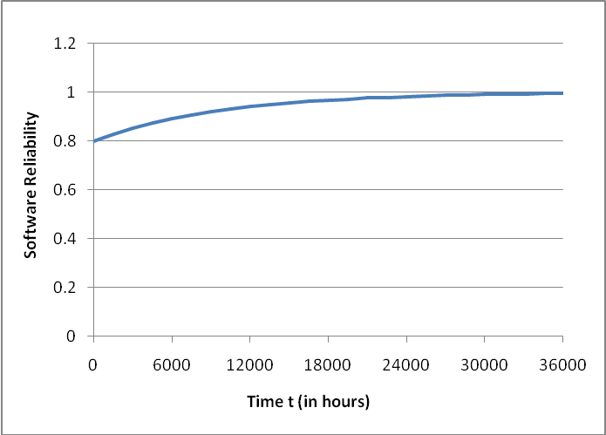

Figure 13. Software reliability over time (λ = 0.0001, ξ = 0.8)
On the other hand, hardware reliability can be represented by Weibull distribution [27]. The corresponding formula to calculate the reliability of a hardware component can be defined as in (2).
R_{hardware} (t) = exp [– (βt) ^{α}] (2)
where α is the shape parameter (α > 0), and β is the scale parameter (β > 0). Fig.14 shows how the hardware reliability changes over time when α = 2 and β = 0.00002. From the figure, we can see that the hardware reliability decreases with time. This is because after a certain age, the product enters its wear-out phase and the failure rate starts to increase.
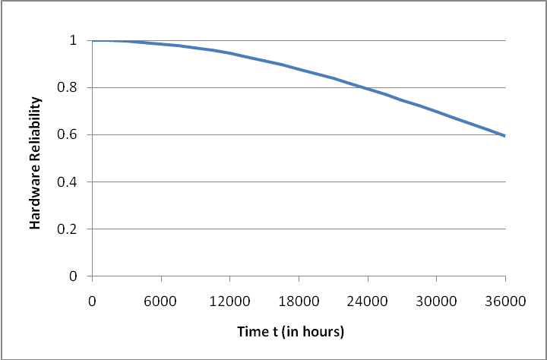
Figure 14. Hardware reliability over time (α = 2, β = 0.00002)
Bowles tried to derive a combined hardware and software reliability model for networks [28]. According to [28], “The probability of successful operation of a device is the probability that the hardware does not fail and the probability that the software does not fail.” Inspired by this idea, in this thesis, we calculate web service reliability by considering both the reliability of the software component (i.e., web service) and the reliability of the machine where the web service is deployed. For simplicity, we assume that a web service is initially deployed on a new machine with the perfect reliability of 1. Thus, time t can be defined as t = tcurrent – t0, where tcurrent is the time when the reliability is calculated and t0 is the time when the web service is deployed. The hybrid reliability model for atomic web service can be defined as in (3).
R_{service} (t) = R_{software} (t) * R_{hardware} (t)
= {(1 – exp [– (λt)]) * (1 – ξ) + ξ} * exp [– (βt) ^{α}]} (3)
where Rsoftware(t) is the reliability function of the web service and Rhardware(t) is the reliability function of the machine that hosts the web service. Fig. 15 shows how the reliability of a deployed atomic web service changes over time when λ = 0.0001, ξ = 0.8, α = 2, and β = 0.00002.
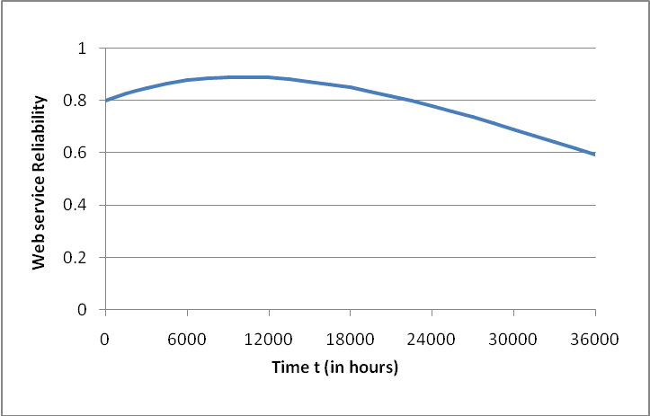
Figure 15. Web service reliability over time
As shown in the fig. 15, the reliability growth has been experienced initially which can be attributed to the software aspect, i.e., fault corrections being made to the web service. Then, after some time, the reliability starts decreasing. This is because the hardware starts to degrade with time.

5.3 Reliability Model for Composite Web Services
The aggregate reliability of a composite web service depends on its structure, the degree of independence between services and the availability of substitutes of web services [7]. In order to calculate the reliability of a composite web service, we first need to consider the reliability of the major structural components. Based on previous work [9, 10, 11], we now define the reliability model for each structural component as follows.

5.3.1 Sequence
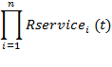
The reliability of a composite web service composed of services in sequence can be calculated as in (4).
Rsequence (t) = (4)

where the constitutive web services service_{i} (1 ≤ i ≤ n) are all independent of each other (i.e., the failure of one service does not lead to the failure of the others), and Rservice_{i}(t) is the reliability function of each constitutive atomic or composite web service.

5.3.2 Parallel
The reliability of a composite web service composed of services in parallel can be calculated as in (5).
Rparallel (t) = (5)
where the constitutive web services service_{i} (1 ≤ i ≤ n) are all independent of each other. Note that the failure of any constitutive web service results in the failure of the composite web service because the successful termination of the latter requires the successful termination of all of its constitutive web services.

5.3.3 Loop
The reliability of a composite web service composed of web services in a loop can be calculated as in (6).

Rl_{oop} (t) = min _{0≤i≤n} (R_{service_loopbody} (t + i * Δt) (6)
where Rservice_loopbody(t) is the reliability function of the loop body that can be an atomic web service or composite one; n is the number of iterations; and Δt is the execution time of each iteration. When n*Δt is not a large value, the reliability of the loop structural component would be approximately the same as when it was executed the first time.

5.3.4 Choice
The reliability of a composite web service composed of web services in choice can be calculated as in (7).
R_{choice} (t) = min _{1≤i≤n} (R_{service_i} (t)) (7)
Since we consider the worst-case scenario, the reliability of a choice structural component equals the minimal reliability of the constitutive web services.

5.3.5 Redundancy
The reliability of a composite web service composed of redundant services can be calculated as in (8).
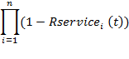
Rredundant (t) = 1 – (8)
Note that a composite web service with redundant components fails if and only if all of its constitutive services service_{i} (1 ≤ i ≤ n) have failed.

5.4 Algorithm: Composite Web Service Reliability Calculation
The algorithm for calculating the reliability of a composite web service is defined recursively as in Algorithm 2 in Figure 16. Algorithm 2 involves two steps when calculating the reliability of a composite web service. In its first step, the reliabilities of all simple components are calculated. In a case when a simple component is bound to a composite web service, the method CalculateReliability must be invoked recursively with the parameter initialization being true. In the second step, the reliabilities of the structural components are calculated. Similarly, when a structural component contains another structural component as its constitutive component, the method CalculateReliability is also invoked recursively, but this time, the parameter initialization is set to false indicating that the algorithm is now processing its second step.

Algorithm 2: Calculate composite web service reliability
Input: path of an ipm file for a composite web service
Output: the real-time reliability of the composite web service
1. CalculateReliability (String fname.ipm, Boolean initialization,
2. StructuralComponent structcom)
3. initialize reliability to 1
4. if (initialization == true) // step 1
5. extract the process model from file fname.ipm and store it in process_model
6. foreach simple component sc in process_model
7. if (sc.service_type == “atomic”)
8. calculate sc.realtime_reliability
9. else sc.realtime_reliability = // sc is “composite”
10. CalculateReliability(sc.ipm, true, null)
11. if (fname.ipm == null) // step 2
12. strc = main structural component of structcom
13. else strc= main structural component of process_model
14. if (strc is sequenceComponent)
15. foreach component com in strc
16. if (com is simpleComponent)
17. reliability *= com.realtime_reliability
18. else reliability *= CalculateReliability(null, false, com)
19. else if (strc is parallelComponent)
20. foreach component com in strc
21. if (com is simpleComponent)
22. reliability *= com.realtime_reliability
23. else reliability *= CalculateReliability(null, false, com)
24. else if (…) // other cases: redundant component,
25. … // loop component, and choice component
26. return reliability

Figure 16. Algorithm 2: Calculation of reliability

Chapter 6

CASE STUDY
To demonstrate the effectiveness of our approach, we utilize a case study of financial services, which involves investment in mutual funds and stocks.

6.1 Process Model
We define a process model for financial investment as a composite web service with a choice structure. As shown in Fig. 17, the main structure involves a choice between buying mutual funds or stocks. These choices are explained in detail in following sub-sections.

6.1.1 Choice 1: Mutual funds
The upper structural component represents mutual fund investment wherein the investor has a choice of investing in three types of mutual funds. They are equity that involves high risk, high gain funds, debt that represents low risk low gain funds, and balanced fund that gives almost steady gain with medium risk.
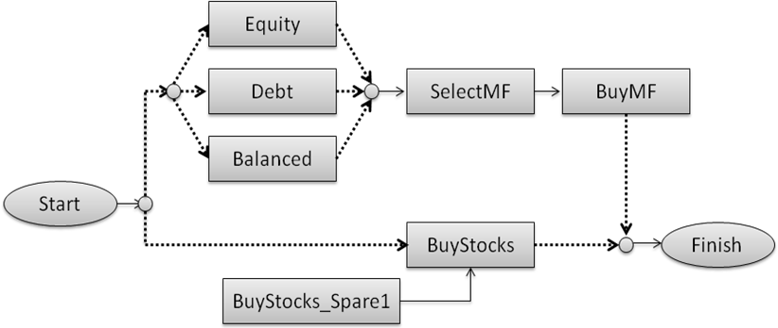
Figure 17. A process model for financial investment
If an investor wants to invest in mutual funds, he/she needs to provide the following information: name, type of mutual fund he/she wants to invest in and number of funds that he/she intends to buy. Based upon his choice of fund, equity, debt or balanced web service would be invoked. The Equity web service returns a list of equity mutual funds along with their returns. Similarly, Debt and Balanced web services return a list of debt mutual funds with returns and a list of balanced mutual funds with returns respectively. Then, the SelectMF service is invoked. It requires a list of mutual funds along with their returns as an input. It chooses the mutual fund with best returns amongst them and returns that as an output. Finally, the BuyMF service will be invoked to buy the selected mutual fund. It requires a mutual fund name as an input. The mutual fund chosen by SelectMF service is sent as an input to BuyMF service. Then, it buys the numbers of funds that the investor had initially requested.

6.1.1 Choice 2: Stocks
On the other hand, if buying stock is chosen, the process model has the BuyStocks service (Main) with a redundant one, namely BuyStocks_Spare1 (Spare). The input to this service is the investor’s name, name of the stock to be bought, the number of stocks, and the rate at which the user wants to buy. When the specified stock is available at the preferred rate, the BuyStocks service buys the specified number of stocks. When the reliability of the BuyStocks service becomes unacceptable, BuyStocks_Spare1 is activated to substitute it as they both are functionally equivalent. For this case study, we designed two composite web services that would match with BuyStocks web services; namely BuyStocks1 and BuyStocks3. That means a direct WSDL file would not be available for BuyStocks web services. We designed BuyStocks1 as a sequence of two components namely CheckAvailability and BuyStk (shown in Fig. 16).
Figure 18. BuyStocks1 process model
CheckAvailability service checks if a particular stock is available at the rate requested by the investor. If it is available, the BuyStk web service is invoked which buys the requested number of stocks. BuyStocks3 web service is also designed in a similar manner as BuyStocks1. BuyStocks3 has CheckAvailability1 and BuyStk1 in sequence.
Depending upon their reliabilities, one of these web services, BuyStocks1 or BuyStocks3 would match with BuyStocks component (more reliable one) and the other one would match with the BuyStocks_Spare1 component at runtime. For example, if the BuyStocks main component matches with the BuyStocks1 web service (shown in Fig 18). Then, BuyStocks_Spare1 component would match with BuyStocks3 service. Now, if both the constituent services of BuyStocks1: CheckAvailability and BuyStk are working fine, then BuyStocks1 successfully delivers the output. But if any of these services cease to run and BuyStocks1 cannot complete its execution, the redundant component’s matched service BuyStocks3 would be invoked immediately to take over.

6.2 Graphical User Interface (GUI)
In order to ensure the desired reliability of the financial services for investment, we develop a prototype service reliability monitoring tool. Fig. 19 shows the interface for
monitoring the reliability of the financial investment service in real-time.
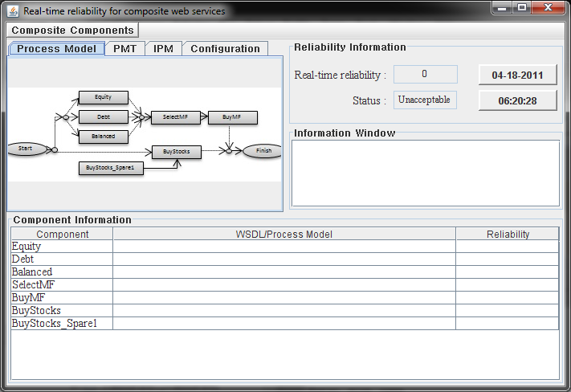
Figure 19. Interface for monitoring real-time web service reliability
The upper left part of the GUI has four tabs: Process Model, PMT, IPM and Configuration. In Fig. 19, the content of the Process Model tab is visible which presents the predefined process model (as shown in Fig. 17). The content of the second tab PMT is shown in Fig. 20. It displays the text of the Process Model Template file for the process model shown in Fig.17. This file has the information about the OWL-S Profile Template of all the components defined in the process model which will be used to query OWL-S/UDDI for finding matching web services. The third tab IPM displays information about the IPM file related to this PMT. It is initially empty and gets filled only after the instantiation process. The content of the fourth tab Configuration is shown in Fig.21.
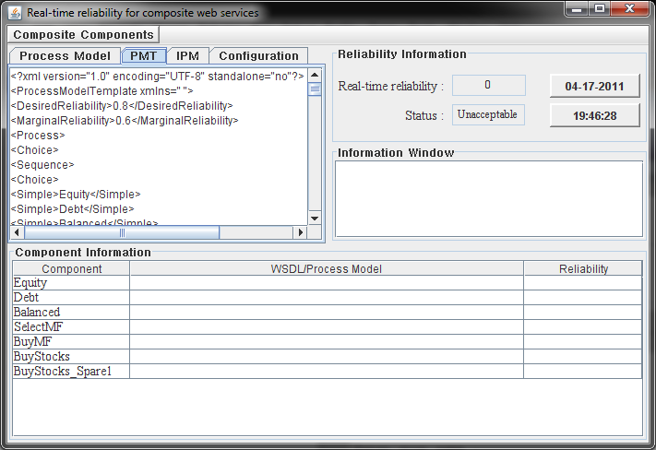
Figure 20. GUI showing the PMT file
Fig.21 displays the Desired and Marginal reliability values which are currently set to 0.8 and 0.6. These values can be easily re-configured by changing the values and clicking the Update button.
The upper right part of the GUI displays the real-time reliability of the process model. It also displays the status of the real-time reliability which could be normal, warning or unacceptable depending upon the values of desired and marginal reliabilities. A normal status indicates that the reliability of the composite web service equals to or more than the desired reliability; a warning status indicates that the reliability is below the desired reliability but no lower than the marginal reliability. When the real-time reliability of the composite web service falls below the desired reliability, some services with low reliabilities must be replaced by others in order to improve its QoS. This is done by activating redundant ones or by searching the OWL-S/UDDI again at runtime for matched services with higher reliabilities, and binding them with the corresponding simple components in the PMT dynamically. In our current prototype, this function is not implemented; however, we envision it as a future research direction. Also, when the reliability falls below the marginal reliability, the status becomes unacceptable and in this the service should stop working.
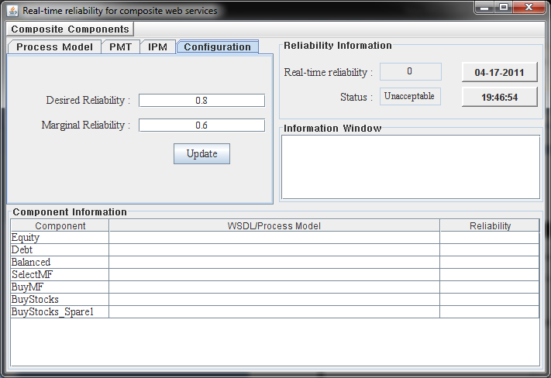
Figure 21. GUI showing the Configuration details
If the desired or marginal reliability values are changed, corresponding effect (if any) can be seen in the reliability status too. The current date and time are also displayed in the upper right corner of the GUI. These values are used in calculating the real-time reliability. The GUI also has an Information Window which shows runtime details of instantiation of PMT, execution of IPM and reliability calculation.
The bottom part of the GUI displays a table, Component Information with three columns. In the first column, all the components of the process model are listed. The second column is filled with the WSDL/ Process model values after the most reliable web services for these components have been found out. If the match is an Atomic web service then its WSDL address is listed here. Otherwise if the match is a composite one, then the location of the IPM file of the composite service is listed here. The last column displays the real-time reliability values of all the components.
Until now the PMT was not initialized. Before the instantiation takes place, the user is required to enter the necessary information which helps decide the course of execution. The most important information the user needs to enter here is type of investment he/she is interested in: Mutual funds or Stocks. Fig. 22 shows an example of the user input where the investor prefers Mutual funds. After the investor chooses to invest in Mutual funds, he/she has to make another choice regarding which type of Mutual fund to invest in. Fig. 22 shows that the investor chose Debt Mutual fund. Now, the investor needs to enter the number of funds he/she is interested in buying (100 in the example). After the user has entered all the needed values, the PMT is instantiated and then the resultant IPM is executed. Fig. 23 shows the output of the execution for the above scenario. If the investor had preferred Stocks, then he/she would need to enter different set of details. Fig. 24 shows an example of user input where the investor chose to invest in stocks. The output of execution is shown in Fig. 25.
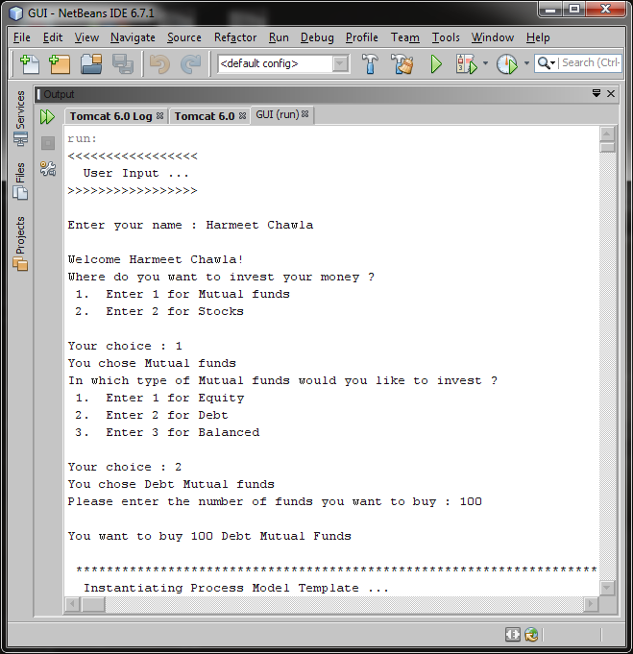
Figure 22. Example of User Input (Mutual fund selected)
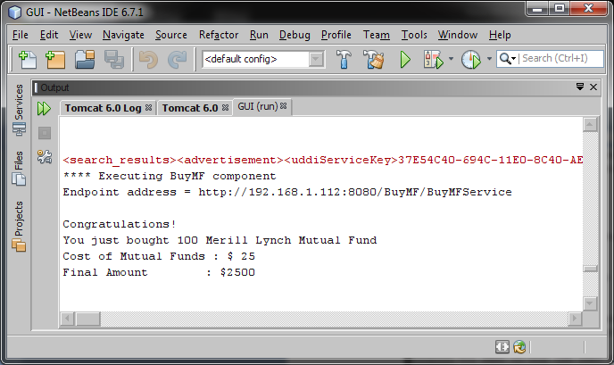
Figure 23. Output of executing IPM corresponding to user input in Fig. 20
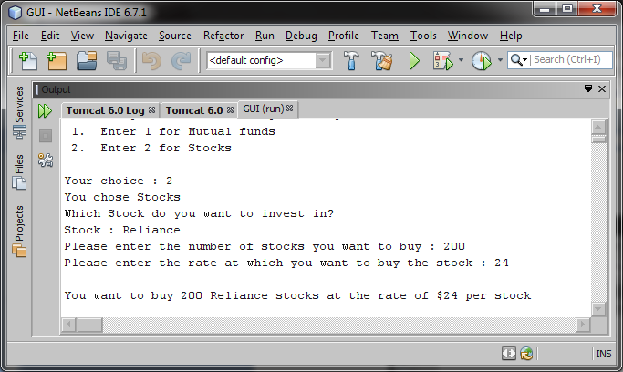
Figure 24. Example of User Input (Stocks selected)
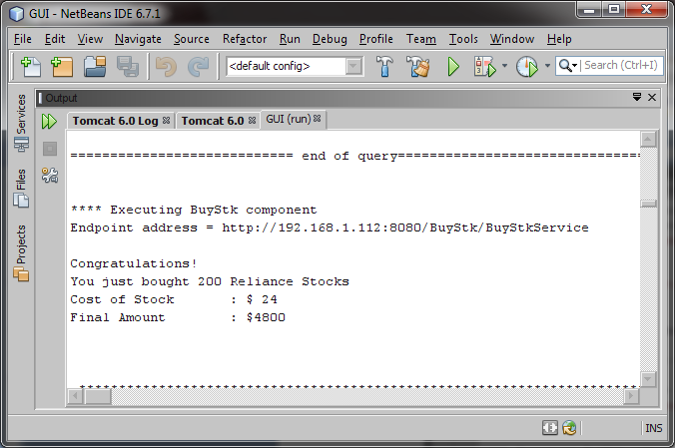
Figure 25. Output of executing IPM corresponding to user input in Fig. 22
After the execution of the IPM, the reliability of the process model is calculated in real-time. As soon as the instantiation process starts, the “Information Window” starts to display the execution information in real-time as shown in a snapshot in Fig. 26.
After the instantiation process and reliability calculation is complete, the related information is filled in the GUI as shown in Fig.27. As we can see from the figure, the real-time reliability is updated and its status is set to Normal as its value, .99512 is greater than the desired reliability which is 0.8. The components: Equity, Debt, Balanced, SelectMF and BuyMF got matched with an Atomic web service. Therefore, their WSDL addresses are displayed. BuyStocks and BuyStocks_Spare1 got matched with composite web services: BuyStocks1 and BuyStocks3 respectively. The real-time reliabilities of all the components can also be seen in the third column. On clicking the IPM tab, the IPM file can be accessed as shown in Fig. 28. As mentioned above, the values of desired and marginal reliabilities can be directly changed from the GUI itself. For example, if we change the desired reliability value to .99600 and the marginal reliability value to .99500 (shown in Fig. 29), the status of the real-time reliability changes to “Warning” as the real-time reliability at that point in time was less than the desired reliability but more than the marginal reliability (.99600 ≤ .99514 < .99500).
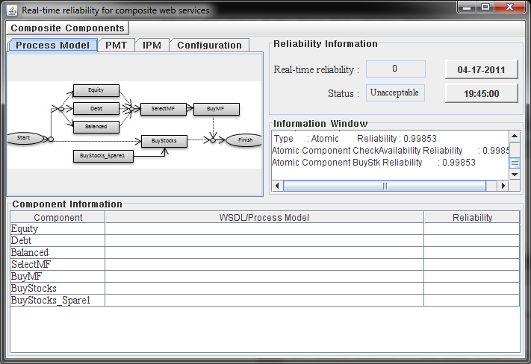
Figure 26. Information Window displaying execution information
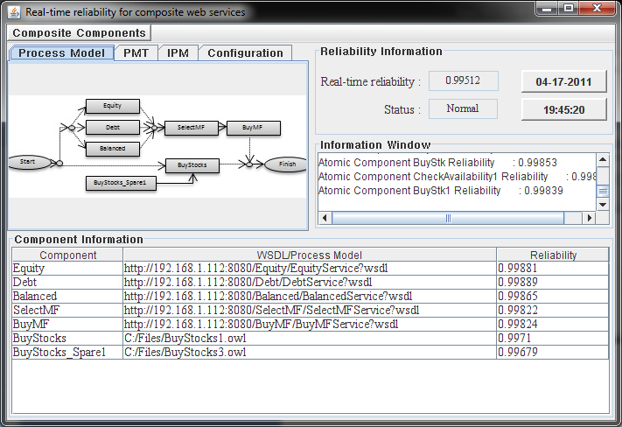
Figure 27. GUI after instntiation of PMT
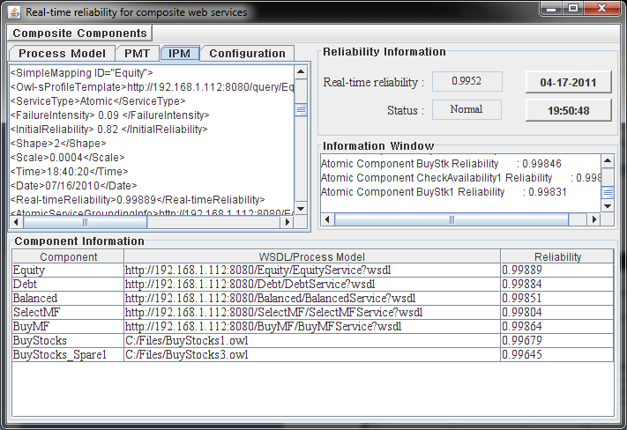
Figure 28. IPM file displayed on clicking the IPM tab
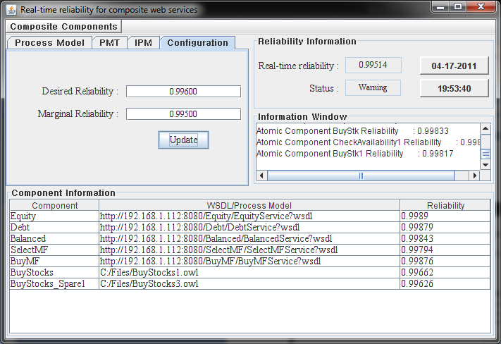
Figure 29. Re-configuration of desired and marginal reliabilities
Since the BuyStocks and BuyStocks_Spare1 matched with composite web services, these services also have their process models. The detailed information about a composite web service can be retrieved by clicking on the Composite Components menu at the top of the interface and then selecting the required menu. As can be seen from Fig.30, the menu bar has three menus: Original, BuyStocks1 and BuyStocks3. Clicking the BuyStocks1’s menu item, “Detailed Info” updates the contents of the table and displays the Component Information of all the components that constitute BuyStocks1 composite web service. The information in the tabbed pane also changes accordingly. Process model tab now displays the structure for BuyStocks1 composite service. Clicking on PMT tab and IPM tab displays the PMT file and IPM file respectively. The Configuration tab shows the desired and marginal reliability values for the new process model. Fig. 31 shows the snapshot of the frame when BuyStocks1 menu is clicked. The Component Information table displays information about two components: CheckAvailability and BuyStk. As can be seen from the figure, they both matched with atomic web services, so the BuyStocks1 service is fully initialized. Fig. 32 shows the IPM file for BuyStocks, displayed on clicking the IPM tab. In the same manner, clicking on BuyStocks3’s menu item, “Detailed Info” would show its detailed information. Now, to return to our process model, we can select the Original menu from the menubar. This would again update the tabbed pane and Component Information to what it was initially.
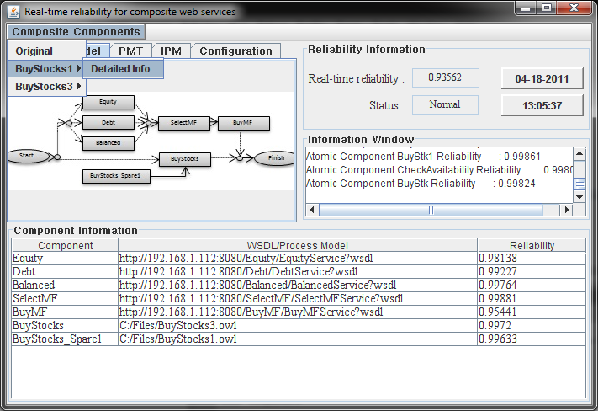
Figure 30. Menus of the Composite Components menubar
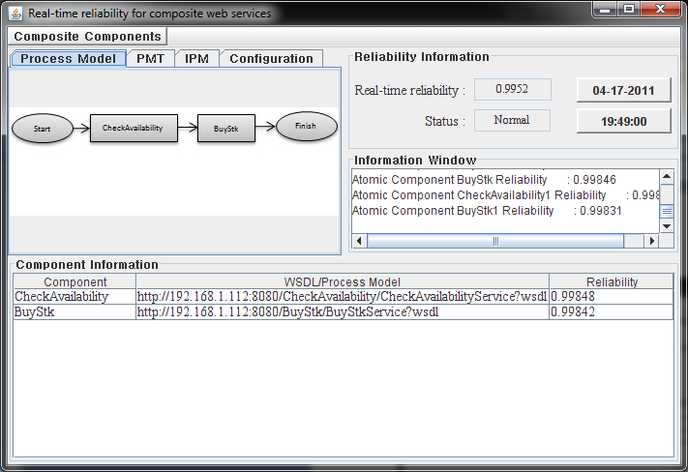
Figure 31. Process model for BuyStocks1
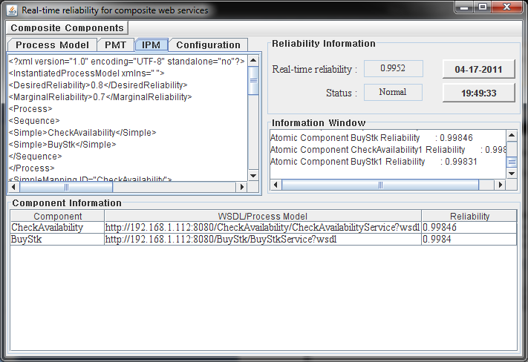
Figure 32. IPM file for BuyStocks1

Chapter 7

CONCLUSIONS AND FUTURE WORK
In this thesis, we define a dynamic process model that consists of various constructs for web service composition. In addition to the basic structural components, we have introduced a new construct, i.e., the Redundancy construct, which helps in making the composite web services more reliable. The dynamic process model is initially defined as a process model template, called PMT, where the constitutive components are not bound to any specific web services. It defines the structure in which components are arranged. PMT only contains information about the component names and their corresponding OWL-S Profile Templates (which help in querying the OWL-S/UDDI for finding matching web services). At runtime, the PMT is instantiated into a set of instantiated process models or IPMs. During the instantiation process, web services that are matched with the simple components defined in a PMT are discovered and selected based on their real-time reliability values. In order to calculate the reliabilities of composite web services, we first present a hybrid reliability model for atomic web services which considers both software and hardware aspects in reliability calculation. Then we define a real-time reliability model for a composite web service that aggregates the reliabilities of its constitutive components according to the definition of its dynamic process model. Our approach not only supports reliable service selection for dynamic web service composition, but also supports maintaining a reliable composite web service at runtime by monitoring the service reliabilities in real-time.
For future work, we will demonstrate how to automatically switch a web service to a reliable one when its reliability becomes unacceptable. We envision creating a real-time service reliability monitoring tool with the function of dynamic service replacement a more ambitious research direction. We will consider utilizing artificial intelligence techniques to define a better service reliability model that can automatically adjust its parameters at runtime. In addition, integrating the proposed reliability index into some existing approaches [12, 13] can also be considered as a worthy future direction.

REFERENCES
- J. Rao and X. Su, “A Survey of Automated Web Service Composition Methods,” in Proc. of the First Int. Workshop on Semantic Web Services and Web Process Composition (SWSWPC 2004), San Diego, CA, USA, pp. 43-54, Jul. 2004.
- N. Channa, S. Li, A.W. Shaikh, and X. Fu, “Constraint Satisfaction in Dynamic Web Service Composition,” In Proc. of the 16th Int. Workshop on Database and Expert Systems Applications (DEXA'05), pp. 658-664, 2005.
- Y. Jeon, E. Song, M. Guo, L. T. Yang, Y. Jeong, and S. Han, “Ontology-Based Composition of Web Services for Ubiquitous Computing,” Lecture Notes in Computer Science (LNCS), vol. 4331, pp. 559-568, 2006.
- D. Martin, M. Paolucci, S. McIlraith, M. Burstein, D. McDermott, D. McGuinness, et al., “Bringing Semantics to Web Services: The OWL-S Approach,” in Proc. of the First Int. Workshop on Semantic Web Services and Web Process Composition (SWSWPC 2004), San Diego, CA, USA, pp. 26-42, Jul. 2004.
- B. Johnson, “The Design and Analysis of Fault-Tolerant Digital Systems”, Addison-Wesley, New York, 1988.
- S. Ran, “A Model for Web Services Discovery with QoS”, ACM SIGecom Exchanges, Vol. 4 Issue 1, March 2003.
- H. Zo, D. L. Nazareth, and H. K Jain, “Measuring Reliability of Applications Composed of Web Services,” in Proc. of the 40th Annual Hawaii Int. Conf. on System Sciences (HICSS’07), pp. 278c, 2007.
- L. Zeng, B. Benatallah, M. Dumas, J. Kalagnanam, and Q.Z. Sheng, “Quality Driven Web Services Composition”, In Proc. Of 12th Int. Conf. World Wide Web (WWW), May 2003.
- B. Li, Z. Su, Y. Zhou, and X. Gong, “A User-Oriented Web Service Reliability Model,” In Proc. of the IEEE Int. Conf. on Systems, Man and Cybernetics, Singapore, pp. 3612-3617, Oct. 2008.
- W. T. Tsai, D. Zhang, Y. Chen, H. Huang, R. Paul, and N. Liao, “A Software Reliability Model for Web Services,” in Proc. of the 8th IASTED Int. Conf. on Software Engineering and Applications (SEA 2004), Cambridge, MA, pp. 144-149, Nov. 2004.
- S.-Y. Hwang, H. Wang, J. Tang, and J. Srivastava, “A Probabilistic Approach to Modeling and Estimating the Qos of Web-Services-Based Workflows,” Information Sciences, vol. 177, no. 23, pp. 5484-5503, Dec. 2007.
- J. Ma, Y. Zhang, and M. Li, “OMWSC - An Ontology-Based Model for Web Services Composition,” in Proc. of the 5th Int. Conf. on Quality Software (QSIC 2005), Melbourne, Australia, pp. 464-469, Sept. 2005.
- P. C. Xiong, Y. Fan, and M. C. Zhou, “Web Service Configuration under Multiple Quality-of-Service Attributes,” IEEE Trans. on Automation Science and Engineering, vol. 6, no. 2, pp. 311-321, Apr. 2009.
- W. Tan, Y. Fan, M. C. Zhou, and Z. Tian, “Data-driven Service Composition in Building SOA Solutions: A Petri Net Approach,” IEEE Trans. on Automation Science and Engineering, vol. 7, no. 3, pp. 686-694, Jul. 2010.
- H. Jin, X. Xie, Y. Li, Z. Han, and H. Chen, “Athena: A Real-Time Performance Evaluation for Distributed Software with Reliability Constraints,” in Proc. of the 18th Int. Symp. on Parallel and Distributed Processing, Santa Fe, New Mexico, pp. 247-252, Apr. 2004.
- R. Geist, A. J. Offutt, and F. C. Harris, “Estimation and Enhancement of Real-Time Software Reliability Through Mutation Analysis,” IEEE Trans. on Computers, vol. 41, no. 5, pp. 550-558, May 1992.
- V. Beal, “Understanding Web Service,” http:// www.webopedia.com/ DidYouKnow/Computer_Science/2005/web_services.asp, September 1, 2010.
- N. Balani and R. Hathi, “Design and Develop JAX-WS 2.0 Web Services”, http://www.ibm.com/developerworks/webservices/tutorials/ws-jax/, September 20, 2007.

- M. Horridge, H. Knublauch, A. Rector, R. Stevens, and C. Wroe, “A Practical Guide to Building OWL Ontologies using The Protégé -OWL Plugin and CO- ODE Tools Edition 1.0,” http://owl.cs.manchester.ac.uk/tutorials/protegeowltutorial/resources/ ProtegeOWLTutorialP4_v1_1.pdf, August 27, 2004.
- S. Saadati and G. Denker, “An OWL-S Editor Tutorial, Version 1.1,” http://owlseditor.semwebcentral.org/documents/tutorial.pdf, 2005.
- D. Martin, M. Burstein, J. Hobbs, O. Lassila, et al., “OWL-S: Semantic Markup for Web Services”, W3C Member Submission, November 22, 2004.
- “Universal Description Discovery and Integration”, http:// en.wikipedia.org/ wiki/ Universal_Description_Discovery_and_Integration, April 3, 2011.
- N. Srinivasan, M. Paolucci, and K. Sycara, “Adding OWL-S to UDDI, Implementation and Throughput”, In Proc. of the First Int. Workshop on Semantic Web Services and Web Process Composition, USA, 2004.
- “Mutual Funds: Introduction”, http:// www.investopedia.com/ university/ mutualfunds/default.asp, last accessed on April 22, 2011.
- M. R. Lyu, “Software Reliability Engineering: A Roadmap,” in Proc. of the Workshop on Future of Software Engineering (FOSE’07), Int. Conf. on Software Engineering, Washington, DC, pp.153-170, 2007.
- H. Pham, “System Software Reliability”, Springer-Verlag, London, 2006.
- C. D. Lai, M. Xie and D. N. P. Murthy, “A Modified Weibull Distribution,” IEEE Trans. on. Reliability, vol. 52, no. 1, pp. 33-37, Mar. 2003.
- J. B. Bowles, “A Model for Assessing Computer Network Reliability,” in Proc. of the IEEE Conf. on Energy and Information Technologies in the Southeast (SoutheastCon), Columbia, SC, USA, pp. 603-608, Apr. 1989.

